Coronavirus disease 2019 (COVID-19)
Situation Report – 64

Data as reported by national authorities by 10:00 CET 24 March 2020

HIGHLIGHTS
- Four new countries/territories/areas from the South-East Asia Region [1], and Region of the Americas [3] have reported cases of COVID-19.

- WHO has delivered a new shipment of emergency medical supplies to the Islamic Republic of Iran as part of COVID-19 response measures. Details can be found on the WHO Regional Office for the Eastern Mediterranean here.

- The WHO WhatsApp Health Alert has now attracted 10 million users since launching Friday, and the COVID-19 Solidarity Response Fund has raised more than US$70 million, in just 10 days. The media briefing can be found here.
- WHO and FIFA launched a joint campaign to equip the football community to tackle COVID-19. This awareness campaign calls on all people around the world to follow the five key steps to stop the spread of the disease. More information can be found here.
- WHO and its partners are constantly working to strengthen the chains of essential COVID-19 supplies. As global demand rises, WHO and its partners aim to ensure assistance to areas most in need. More information can be found in Subject in Focus.
SITUATION IN NUMBERS
total (new) cases in last 24 hours

Globally
372 757 confirmed (39 827)
16 231 deaths (1722)
Western Pacific Region
96 580 confirmed (943)
3502 deaths (29)

European Region
195 511 confirmed (24 087)
10 189 deaths (1447)

South-East Asia Region
1990 confirmed (214)
65 deaths (7)

Eastern Mediterranean Region
27 215 confirmed (1840)
1877 deaths (136)

Region of the Americas
49 444 confirmed (12 428)
565 deaths (100)

African Region
1305 confirmed (315)
26 deaths (3)

WHO RISK ASSESSMENT
Global Level Very High

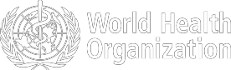

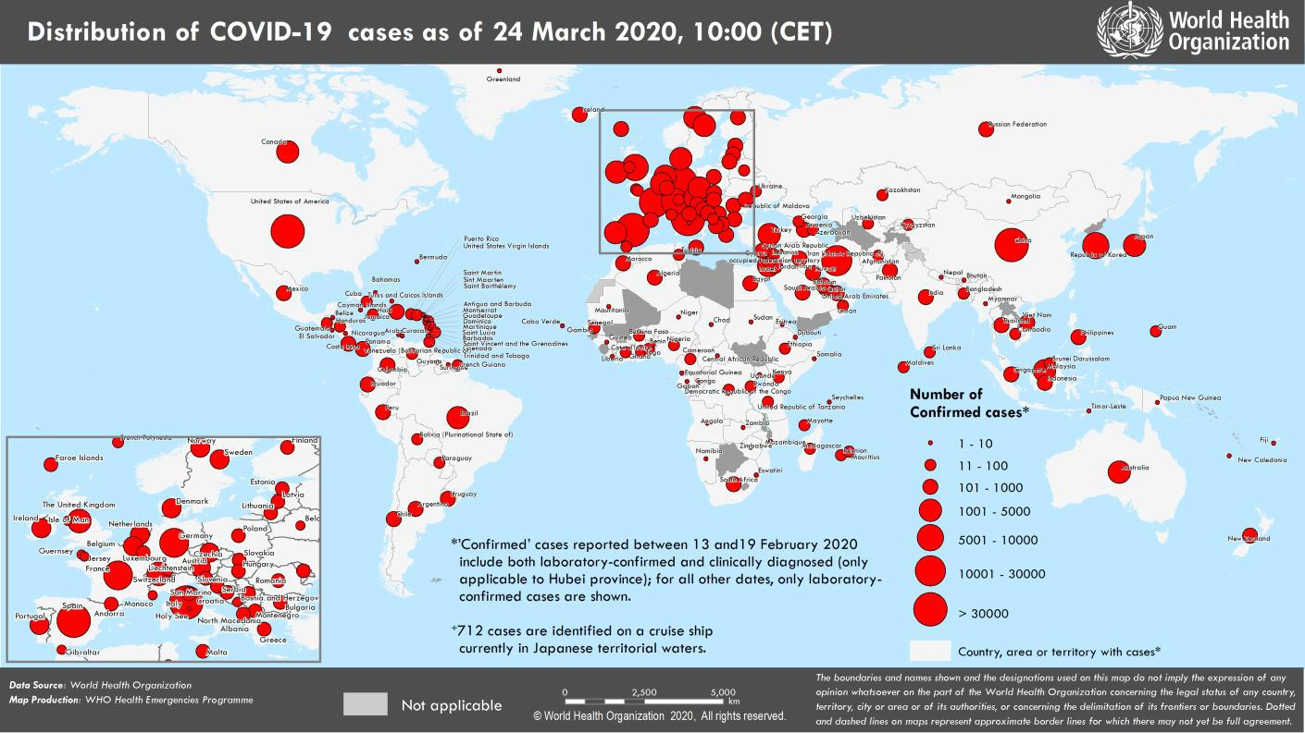
Figure 1. Countries, territories or areas with reported confirmed cases of COVID-19, 24 March 2020

SUBJECT IN FOCUS: STRENGTHENING SUPPLY CHAINS TO CREATE GREATEST IMPACT

WHO and the World Food Programme (WFP) are exploring ways to work with the Pandemic Supply Chain Network (PSCN) and Logistical Emergency Teams (L.E.T.) to ensure that logistical assets are in place to support the increasing global demand for COVID-19 supplies. This is to ensure that supplies are allocated effectively and equitably in the places where they are needed the most.

WHO is also working with the World Bank to develop demand modeling from a country-based perspective. This will allow the sharing and support of technical guidance and allocation mechanisms and ensure that critical supplies are distributed with most impact.

The planning effort will support the mapping of scenarios as well as what is needed for stocks and procurement. With the engagement of the World Bank, the PSCN seeks to bring together the overview of the market’s capability to provide and distribute the necessary supplies, WHO demand forecasting and the necessary financial and political support to fight COVID-19.

Representatives from both WFP and the United Nations Office for the Coordination of Humanitarian Affairs (OCHA) have joined the WHO team at HQ to establish the Supply Chain Coordination Cell (SCCC). The objectives of the SCCC are to:

- Establish a COVID-19 supply chain working group to deepen inter-agency collaboration with the aim of minimizing disruptions to current humanitarian operations, while increasing efficiency and coherence of the COVID-19 response.
- Provide a centralized voice through the collection and dissemination of information to the UN Crisis Management Team (UNCMT), other relevant forums, as well as the wider humanitarian community, to support strategic guidance, operational decision-making, and overall monitoring.
- Foster the creation of regional and country level coordination mechanisms aimed at implementing efforts, while maintaining the overall coordination of the response.
- Create a smaller joint procurement group of medical equipment buying agencies.

WHO and its partners are constantly working to strengthen the chains of essential COVID-19 supplies. As global demand rises, WHO and its partners aim to ensure that those areas most at need receive as much assistance as much as possible.
SURVEILLANCE

Table 1. Countries, territories or areas with reported laboratory-confirmed COVID-19 cases and deaths. Data as of 24 March 2020*
Reporting Country/ Territory/Area† | Total confirmed  ‡ cases | Total confirmed new cases | Total deaths | Total new deaths | Transmission classification§ | Days since last reported case
Western Pacific Region
China | 81747 | 146 | 3283 | 7 | Local transmission | 0
Republic of Korea | 9037 | 76 | 120 | 9 | Local transmission | 0
Australia | 1709 | 313 | 7 | 0 | Local transmission | 0
Malaysia | 1518 | 212 | 14 | 4 | Local transmission | 0
Japan | 1128 | 39 | 42 | 1 | Local transmission | 0
Singapore | 507 | 52 | 2 | 0 | Local transmission | 0
Philippines | 462 | 82 | 33 | 8 | Local transmission | 0
Viet Nam | 123 | 10 | 0 | 0 | Local transmission | 0
New Zealand | 102 | 0 | 0 | 0 | Local transmission | 1
Brunei Darussalam | 91 | 3 | 0 | 0 | Local transmission | 0
Cambodia | 87 | 3 | 0 | 0 | Local transmission | 0
Mongolia | 10 | 0 | 0 | 0 | Imported cases only | 2
Fiji | 3 | 1 | 0 | 0 | Local transmission | 0
Papua New Guinea | 1 | 0 | 0 | 0 | Imported cases only | 3
Territories**
Guam | 29 | 2 | 1 | 0 | Local transmission | 0
French Polynesia | 18 | 1 | 0 | 0 | Local transmission | 0
New Caledonia | 8 | 3 | 0 | 0 | Imported cases only | 0
European Region
Italy | 63927 | 4789 | 6077 | 601 | Local transmission | 0
Spain | 33089 | 4517 | 2182 | 462 | Local transmission | 0
Germany | 29212 | 4438 | 126 | 32 | Local transmission | 0
France | 19615 | 3794 | 860 | 186 | Local transmission | 0
Switzerland | 8015 | 1044 | 66 | 6 | Local transmission | 0
The United Kingdom | 6654 | 967 | 335 | 54 | Local transmission | 0
Netherlands | 4749 | 545 | 213 | 34 | Local transmission | 0
Austria | 4486 | 855 | 25 | 9 | Local transmission | 0
Belgium | 3743 | 342 | 88 | 13 | Local transmission | 0
Norway | 2371 | 239 | 8 | 1 | Local transmission | 0
Portugal | 2060 | 460 | 23 | 9 | Local transmission | 0
Sweden | 2016 | 110 | 25 | 4 | Local transmission | 0
Turkey | 1529 | 293 | 37 | 7 | Local transmission | 0
Denmark | 1460 | 65 | 24 | 11 | Local transmission | 0
Israel | 1238 | 167 | 1 | 0 | Local transmission | 0
Czechia | 1236 | 71 | 1 | 0 | Local transmission | 0
Ireland | 1125 | 219 | 6 | 2 | Local transmission | 0
Luxembourg | 875 | 77 | 8 | 0 | Local transmission | 0
Poland | 749 | 115 | 8 | 1 | Local transmission | 0
Finland | 700 | 74 | 1 | 0 | Local transmission | 0
Greece | 695 | 71 | 17 | 2 | Local transmission | 0
Iceland | 588 | 20 | 2 | 1 | Local transmission | 0
Romania | 576 | 143 | 7 | 5 | Local transmission | 0
Slovenia | 442 | 28 | 1 | 0 | Local transmission | 0
Russian Federation | 438 | 0 | 0 | 0 | Local transmission | 1
Estonia | 352 | 26 | 0 | 0 | Local transmission | 0
Croatia | 306 | 71 | 0 | 0 | Local transmission | 0

Serbia | 249 | 61 | 2 | 2 | Local transmission | 0
Armenia | 235 | 45 | 0 | 0 | Local transmission | 0
Bulgaria | 201 | 16 | 3 | 0 | Local transmission | 0
Slovakia | 191 | 6 | 0 | 0 | Local transmission | 0
Hungary | 187 | 20 | 8 | 1 | Local transmission | 0
San Marino | 187 | 36 | 20 | 0 | Local transmission | 0
Latvia | 180 | 41 | 0 | 0 | Local transmission | 0
Lithuania | 179 | 36 | 1 | 0 | Local transmission | 0
Andorra | 164 | 51 | 1 | 1 | Local transmission | 0
North Macedonia | 136 | 22 | 2 | 1 | Local transmission | 0
Bosnia and Herzegovina | 131 | 6 | 1 | 0 | Local transmission | 0
Albania | 123 | 34 | 4 | 2 | Local transmission | 0
Cyprus | 116 | 21 | 0 | 0 | Local transmission | 0
Republic of Moldova | 109 | 15 | 1 | 0 | Local transmission | 0
Malta | 107 | 17 | 0 | 0 | Local transmission | 0
Ukraine | 84 | 37 | 3 | 0 | Local transmission | 0
Belarus | 81 | 5 | 0 | 0 | Local transmission | 0
Azerbaijan | 72 | 7 | 1 | 0 | Local transmission | 0
Georgia | 67 | 13 | 0 | 0 | Local transmission | 0
Kazakhstan | 63 | 3 | 0 | 0 | Imported cases only | 0
Liechtenstein | 46 | 0 | 0 | 0 | Imported cases only | 1
Uzbekistan | 46 | 0 | 0 | 0 | Local transmission | 1
Monaco | 23 | 0 | 0 | 0 | Local transmission | 1
Montenegro | 22 | 1 | 0 | 0 | Imported cases only | 0
Kyrgyzstan | 16 | 2 | 0 | 0 | Local transmission | 0
Holy See | 1 | 0 | 0 | 0 | Under investigation | 17
Territories**
Faroe Islands | 118 | 3 | 0 | 0 | Local transmission | 0
Kosovo[1] | 61 | 30 | 1 | 0 | Local transmission | 0
Guernsey | 20 | 3 | 0 | 0 | Imported cases only | 0
Jersey | 18 | 3 | 0 | 0 | Local transmission | 0
Gibraltar | 15 | 0 | 0 | 0 | Under investigation | 1
Isle of Man | 13 | 11 | 0 | 0 | Imported cases only | 0
Greenland | 4 | 2 | 0 | 0 | Under investigation | 0
South-East Asia Region
Thailand | 827 | 106 | 4 | 3 | Local transmission | 0
Indonesia | 579 | 65 | 49 | 1 | Local transmission | 0
India | 434 | 19 | 9 | 2 | Local transmission | 0
Sri Lanka | 97 | 15 | 0 | 0 | Local transmission | 0
Bangladesh | 33 | 6 | 3 | 1 | Local transmission | 0
Maldives | 13 | 0 | 0 | 0 | Local transmission | 8
Bhutan | 2 | 0 | 0 | 0 | Imported cases only | 4
Myanmar | 2 | 2 | 0 | 0 | Imported cases only | 0
Nepal | 2 | 1 | 0 | 0 | Imported cases only | 0
Timor-Leste | 1 | 0 | 0 | 0 | Imported cases only | 3
Eastern Mediterranean Region
Iran (Islamic Republic of) | 23049 | 1411 | 1812 | 127 | Local transmission | 0
Pakistan | 887 | 103 | 6 | 1 | Local transmission | 0
Saudi Arabia | 562 | 51 | 0 | 0 | Local transmission | 0
Qatar | 501 | 7 | 0 | 0 | Local transmission | 0
Bahrain | 377 | 40 | 2 | 0 | Local transmission | 0
Egypt | 366 | 39 | 19 | 5 | Local transmission | 0

Lebanon | 267 | 19 | 4 | 0 | Local transmission | 0
Iraq | 266 | 33 | 23 | 3 | Local transmission | 0
United Arab Emirates | 198 | 45 | 2 | 0 | Local transmission | 0
Kuwait | 191 | 2 | 0 | 0 | Local transmission | 0
Morocco | 143 | 28 | 4 | 0 | Local transmission | 0
Jordan | 127 | 15 | 0 | 0 | Imported cases only | 0
Tunisia | 89 | 14 | 3 | 0 | Local transmission | 0
Oman | 84 | 29 | 0 | 0 | Local transmission | 0
Afghanistan | 42 | 2 | 1 | 0 | Imported cases only | 0
Djibouti | 3 | 2 | 0 | 0 | Imported cases only | 0
Sudan | 2 | 0 | 1 | 0 | Imported cases only | 2
Somalia | 1 | 0 | 0 | 0 | Imported cases only | 7
Syrian Arab Republic | 1 | 0 | 0 | 0 | Imported cases only | 1
Territories**
occupied Palestinian territory | 59 | 0 | 0 | 0 | Local transmission | 1
Region of the Americas
United States of America | 42164 | 10591 | 471 | 69 | Local transmission | 0
Brazil | 1546 | 642 | 25 | 14 | Local transmission | 0
Canada | 1432 | 48 | 20 | 1 | Local transmission | 0
Ecuador | 790 | 258 | 15 | 8 | Local transmission | 0
Chile | 746 | 114 | 1 | 0 | Local transmission | 0
Peru | 395 | 77 | 2 | 0 | Local transmission | 0
Mexico | 370 | 119 | 4 | 2 | Local transmission | 0
Panama | 345 | 100 | 6 | 3 | Local transmission | 0
Colombia | 277 | 81 | 3 | 1 | Local transmission | 0
Argentina | 266 | 41 | 4 | 0 | Local transmission | 0
Dominican Republic | 245 | 173 | 3 | 1 | Local transmission | 0
Uruguay | 162 | 27 | 0 | 0 | Imported cases only | 0
Costa Rica | 158 | 41 | 2 | 0 | Local transmission | 0
Venezuela (Bolivarian Republic of) | 70 | 0 | 0 | 0 | Local transmission | 1
Trinidad and Tobago | 51 | 1 | 0 | 0 | Imported cases only | 0
Cuba | 40 | 24 | 1 | 0 | Imported cases only | 0
Honduras | 30 | 4 | 0 | 0 | Local transmission | 0
Bolivia (Plurinational State of) | 27 | 3 | 0 | 0 | Local transmission | 0
Paraguay | 22 | 0 | 1 | 0 | Local transmission | 1
Guatemala | 20 | 2 | 1 | 0 | Local transmission | 0
Jamaica | 19 | 0 | 1 | 0 | Local transmission | 1
Barbados | 17 | 12 | 0 | 0 | Imported cases only | 0
Haiti | 6 | 4 | 0 | 0 | Imported cases only | 0
Guyana | 5 | 0 | 1 | 0 | Local transmission | 5
Bahamas | 4 | 0 | 0 | 0 | Local transmission | 3
El Salvador | 3 | 2 | 0 | 0 | Imported cases only | 0
Saint Lucia | 3 | 1 | 0 | 0 | Imported cases only | 0
Nicaragua | 2 | 0 | 0 | 0 | Imported cases only | 2
Suriname | 2 | 0 | 0 | 0 | Imported cases only | 3
Antigua and Barbuda | 1 | 0 | 0 | 0 | Imported cases only | 10
Belize | 1 | 1 | 0 | 0 | Imported cases only | 0
Dominica | 1 | 1 | 0 | 0 | Imported cases only | 0
Grenada | 1 | 0 | 0 | 0 | Imported cases only | 1
Saint Vincent and the | 1 | 0 | 0 | 0 | Imported cases only | 11

Grenadines
Territories**
Guadeloupe | 62 | 6 | 0 | 0 | Imported cases only | 0
Martinique | 53 | 21 | 0 | 0 | Imported cases only | 0
Puerto Rico | 31 | 8 | 2 | 1 | Imported cases only | 0
French Guiana | 20 | 2 | 0 | 0 | Local transmission | 0
United States Virgin Islands | 17 | 11 | 0 | 0 | Imported cases only | 0
Aruba | 9 | 1 | 0 | 0 | Imported cases only | 0
Saint Martin | 8 | 3 | 0 | 0 | Under investigation | 0
Bermuda | 6 | 4 | 0 | 0 | Imported cases only | 0
Cayman Islands | 5 | 2 | 1 | 0 | Imported cases only | 0
Curaçao | 4 | 1 | 1 | 0 | Imported cases only | 0
Saint Barthélemy | 3 | 0 | 0 | 0 | Under investigation | 8
Sint Maarten | 2 | 1 | 0 | 0 | Imported cases only | 0
Montserrat | 1 | 0 | 0 | 0 | Imported cases only | 6
Turks and Caicos Islands | 1 | 1 | 0 | 0 | Imported cases only | 0
African Region
South Africa | 402 | 128 | 0 | 0 | Local transmission | 0
Algeria | 231 | 30 | 17 | 0 | Local transmission | 0
Burkina Faso | 99 | 24 | 3 | 0 | Local transmission | 0
Senegal | 79 | 12 | 0 | 0 | Local transmission | 0
Cameroon | 72 | 32 | 0 | 0 | Local transmission | 0
Democratic Republic of the Congo | 36 | 6 | 2 | 0 | Local transmission | 0
Mauritius | 36 | 24 | 0 | 0 | Imported cases only | 0
Rwanda | 36 | 19 | 0 | 0 | Local transmission | 0
Ghana | 27 | 3 | 2 | 2 | Local transmission | 0
Côte d’Ivoire | 25 | 0 | 0 | 0 | Imported cases only | 1
Nigeria | 22 | 0 | 0 | 0 | Imported cases only | 2
Togo | 18 | 2 | 0 | 0 | Imported cases only | 0
Kenya | 16 | 1 | 0 | 0 | Local transmission | 0
Madagascar | 13 | 1 | 0 | 0 | Imported cases only | 0
United Republic of Tanzania | 12 | 0 | 0 | 0 | Imported cases only | 1
Ethiopia | 11 | 0 | 0 | 0 | Imported cases only | 1
Uganda | 9 | 8 | 0 | 0 | Imported cases only | 0
Seychelles | 7 | 0 | 0 | 0 | Imported cases only | 2
Equatorial Guinea | 6 | 0 | 0 | 0 | Imported cases only | 2
Gabon | 6 | 0 | 1 | 0 | Imported cases only | 1
Benin | 5 | 3 | 0 | 0 | Imported cases only | 0
Central African Republic | 4 | 0 | 0 | 0 | Imported cases only | 1
Congo | 4 | 0 | 0 | 0 | Imported cases only | 2
Eswatini | 4 | 0 | 0 | 0 | Imported cases only | 1
Guinea | 4 | 2 | 0 | 0 | Imported cases only | 0
Cabo Verde | 3 | 0 | 0 | 0 | Imported cases only | 2
Chad | 3 | 2 | 0 | 0 | Imported cases only | 0
Liberia | 3 | 0 | 0 | 0 | Local transmission | 2
Namibia | 3 | 0 | 0 | 0 | Imported cases only | 4
Zambia | 3 | 0 | 0 | 0 | Imported cases only | 1
Angola | 2 | 0 | 0 | 0 | Imported cases only | 2
Mauritania | 2 | 0 | 0 | 0 | Imported cases only | 5

Niger | 2 | 1 | 0 | 0 | Imported cases only | 0
Zimbabwe | 2 | 0 | 1 | 1 | Imported cases only | 2
Eritrea | 1 | 0 | 0 | 0 | Imported cases only | 2
Gambia | 1 | 0 | 0 | 0 | Imported cases only | 6
Mozambique | 1 | 0 | 0 | 0 | Imported cases only | 1
Territories**
Réunion | 71 | 7 | 0 | 0 | Under investigation | 0
Mayotte | 24 | 10 | 0 | 0 | Imported cases only | 0
Subtotal for all regions | 372045 | 39827 | 16224 | 1722
International conveyance (Diamond Princess) | 712 | 0 | 7 | 0 | Local transmission | 8
Grand total | 372757 | 39827 | 16231 | 1722
*Numbers include both domestic and repatriated cases
†The designations employed and the presentation of the material in this publication do not imply the expression of any opinion whatsoever on the part of WHO concerning the legal status of any country, territory, city or area or of its authorities, or concerning the delimitation of its frontiers or boundaries. Dotted and dashed lines on maps represent approximate border lines for which there may not yet be full agreement.
‡Case classifications are based on WHO case definitions for COVID-19.
§Transmission classification is based on WHO analysis of available official data and may be subject to reclassification as additional data become available. Countries/territories/areas experiencing multiple types of transmission are classified in the highest category for which there is evidence; they may be removed from a given category if interruption of transmission can be demonstrated. It should be noted that even within categories, different countries/territories/areas may have differing degrees of transmission as indicated by the differing numbers of cases and other factors. Not all locations within a given country/territory/area are equally affected.
Terms:
- Community transmission is evidenced by the inability to relate confirmed cases through chains of transmission for a large number of cases, or by increasing positive tests through sentinel samples (routine systematic testing of respiratory samples from established laboratories).
- Local transmission indicates locations where the source of infection is within the reporting location.
- Imported cases only indicates locations where all cases have been acquired outside the location of reporting.
- Under investigation indicates locations where type of transmission has not been determined for any cases.
- Interrupted transmission indicates locations where interruption of transmission has been demonstrated (details to be determined)
** “Territories” include territories, areas, overseas dependencies and other jurisdictions of similar status
[1] All references to Kosovo should be understood to be in the context of the United Nations Security Council resolution 1244 (1999).

Due to differences in reporting methods, retrospective data consolidation, and reporting delays, the number of new cases may not always reflect the exact difference between yesterday’s and today’s totals. WHO COVID-19 Situation Reports present official counts of confirmed COVID-19 cases, thus differences between WHO reports and other sources of COVID-19 data using different inclusion criteria and different data cutoff times are to be expected.

New countries/territories/areas are shown in red.
Figure 2. Epidemic curve of confirmed COVID-19, by date of report and WHO region through 24 March 2020

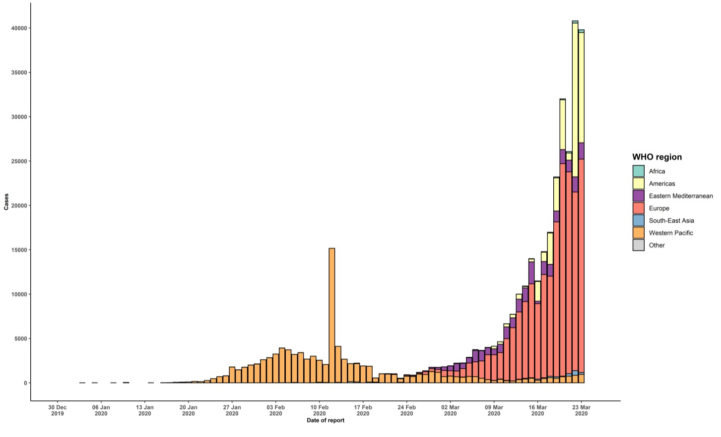

STRATEGIC OBJECTIVES

WHO’s strategic objectives for this response are to:

  - Interrupt human-to-human transmission including reducing secondary infections among close contacts and health care workers, preventing transmission amplification events, and preventing further international spread*;
  - Identify, isolate and care for patients early, including providing optimized care for infected patients;
  - Identify and reduce transmission from the animal source;
  - Address crucial unknowns regarding clinical severity, extent of transmission and infection, treatment options, and accelerate the development of diagnostics, therapeutics and vaccines;
  - Communicate critical risk and event information to all communities and counter misinformation;
  - Minimize social and economic impact through multisectoral partnerships.

*This can be achieved through a combination of public health measures, such as rapid identification, diagnosis and management of the cases, identification and follow up of the contacts, infection prevention and control in health care settings, implementation of health measures for travelers, awareness-raising in the population and risk communication.
PREPAREDNESS AND RESPONSE
- To view all technical guidance documents regarding COVID-19, please go to this webpage.
- WHO has developed interim guidance for laboratory diagnosis, advice on the use of masks during home care and in health care settings in the context of the novel coronavirus (2019-nCoV) outbreak, clinical management, infection prevention and control in health care settings, home care for patients with suspected novel coronavirus, risk communication and community engagement and Global Surveillance for human infection with novel coronavirus (2019-nCoV).
- WHO is working closely with International Air Transport Association (IATA) and have jointly developed a guidance document to provide advice to cabin crew and airport workers, based on country queries. The guidance can be found on the IATA webpage.
- WHO has been in regular and direct contact with Member States where cases have been reported. WHO is also informing other countries about the situation and providing support as requested.
- WHO is working with its networks of researchers and other experts to coordinate global work on surveillance, epidemiology, mathematical modelling, diagnostics and virology, clinical care and treatment, infection prevention and control, and risk communication. WHO has issued interim guidance for countries, which are updated regularly.
- WHO has prepared a disease commodity package that includes an essential list of biomedical equipment, medicines and supplies necessary to care for patients with 2019-nCoV.
- WHO has provided recommendations to reduce risk of transmission from animals to humans.
- WHO has published an updated advice for international traffic in relation to the outbreak of the novel coronavirus 2019-nCoV.
- WHO has activated the R&D blueprint to accelerate diagnostics, vaccines, and therapeutics.
- OpenWHO is an interactive, web-based, knowledge-transfer platform offering online courses to improve the response to health emergencies. COVID-19 courses can be found here. Specifically, WHO has developed online courses on the following topics: A general introduction to emerging respiratory viruses, including novel coronaviruses (available in Arabic, Chinese, English, French, Russian, Spanish, Hindi, Persian, Portuguese, Serbian, and Turkish); Clinical Care for Severe Acute Respiratory Infections (available in English, French, Russian, and Vietnamese); Health and safety briefing for respiratory diseases - ePROTECT (available in English, French, Russian, Indonesian, and Portuguese); Infection Prevention and Control for Novel Coronavirus (COVID-19) (available in Chinese, English, French, Russian, Spanish, Indonesian, Italian, Japanese, Portuguese, and Serbian); and COVID-19 Operational Planning Guidelines and COVID-19 Partners Platform to support country preparedness and response (available in English and coming soon in additional languages).
- WHO is providing guidance on early investigations, which are critical in an outbreak of a new virus. The data collected from the protocols can be used to refine recommendations for surveillance and case definitions, to characterize the key epidemiological transmission features of COVID-19, help understand spread, severity, spectrum of disease, impact on the community and to inform operational models for implementation of countermeasures such as case isolation, contact tracing and isolation. Several protocols are available here. One such protocol is for the investigation of early COVID-19 cases and contacts (the “First Few X (FFX) Cases and contact investigation protocol for 2019-novel coronavirus (2019-nCoV) infection”). The protocol is designed to gain an early understanding of the key clinical, epidemiological and virological characteristics of the first cases of COVID-19 infection detected in any individual country, to inform the development and updating of public health guidance to manage cases and reduce the potential spread and impact of infection.
RECOMMENDATIONS AND ADVICE FOR THE PUBLIC

If you are not in an area where COVID-19 is spreading or have not travelled from an area where COVID-19 is spreading or have not been in contact with an infected patient, your risk of infection is low. It is understandable that you may feel anxious about the outbreak. Get the facts from reliable sources to help you accurately determine your risks so that you can take reasonable precautions (see Frequently Asked Questions). Seek guidance from WHO, your healthcare provider, your national public health authority or your employer for accurate information on COVID-19 and whether COVID-19 is circulating where you live. It is important to be informed of the situation and take appropriate measures to protect yourself and your family (see Protection measures for everyone).

If you are in an area where there are cases of COVID-19 you need to take the risk of infection seriously. Follow the advice of WHO and guidance issued by national and local health authorities. For most people, COVID-19 infection will cause mild illness however, it can make some people very ill and, in some people, it can be fatal. Older people, and those with pre-existing medical conditions (such as cardiovascular disease, chronic respiratory disease or diabetes) are at risk for severe disease (See Protection measures for persons who are in or have recently visited (past 14 days) areas where COVID-19 is spreading).

CASE DEFINITIONS

WHO periodically updates the Global Surveillance for human infection with coronavirus disease (COVID-19) document which includes case definitions.

For easy reference, case definitions are included below.

Suspect case
- A patient with acute respiratory illness (fever and at least one sign/symptom of respiratory disease, e.g., cough, shortness of breath), AND a history of travel to or residence in a location reporting community transmission of COVID-19 disease during the 14 days prior to symptom onset.
OR
- A patient with any acute respiratory illness AND having been in contact with a confirmed or probable COVID-19 case (see definition of contact) in the last 14 days prior to symptom onset;
OR
- A patient with severe acute respiratory illness (fever and at least one sign/symptom of respiratory disease, e.g., cough, shortness of breath; AND requiring hospitalization) AND in the absence of an alternative diagnosis that fully explains the clinical presentation.

Probable case
- A suspect case for whom testing for the COVID-19 virus is inconclusive.
  - Inconclusive being the result of the test reported by the laboratory.
OR
- A suspect case for whom testing could not be performed for any reason.

Confirmed case
A person with laboratory confirmation of COVID-19 infection, irrespective of clinical signs and symptoms.
- Technical guidance for laboratory testing can be found here.

Definition of contact
A contact is a person who experienced any one of the following exposures during the 2 days before and the 14 days
after the onset of symptoms of a probable or confirmed case:
- Face-to-face contact with a probable or confirmed case within 1 meter and for more than 15 minutes;
- Direct physical contact with a probable or confirmed case;
- Direct care for a patient with probable or confirmed COVID-19 disease without using proper personal protective equipment1; OR
- Other situations as indicated by local risk assessments.

Note: for confirmed asymptomatic cases, the period of contact is measured as the 2 days before through the 14 days
after the date on which the sample was taken which led to confirmation.

1 World Health Organization. Infection prevention and control during health care when COVID-19 is suspected https://www.who.int/publications-detail/infection-prevention-and-control-during-health-care-when-novel-coronavirus-(ncov)- infection-is-suspected-20200125

